Invitation to a spring lacemaking workshop

The birds in love

In Slovenia, we have our own version of Valentine’s Day; it is called Gregorjevo – 12th of March (Saint Gregory´s Day) and is linked to an old folk custom announcing that birds are getting married
and spring is coming.

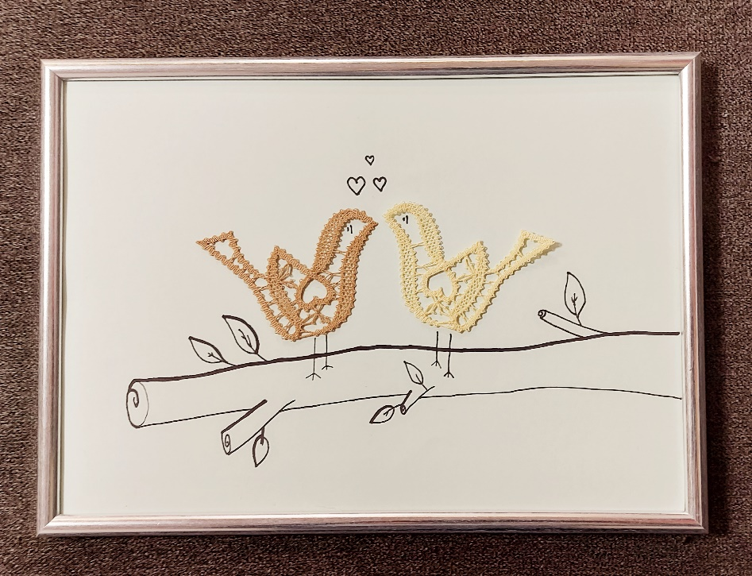
Techniques and elements of Idrija lace: .divided cloth stitch with halfstitch, narrow cloth stitch with corners and plaited leaf.
For workshop you need: lacemaking equipment, 7pairs of bobbins with cotton thread no. 30.
Workshop is not suitable for beginners.
The workshop will be held on Saturday, 16.3.2024, from 9.00 a.m. to 12.45 in two ways:
- in English live in Idrija Lace school in Idrija, Prelovčeva 2 street. You can pay before the workshop.
- in English ONLINE: via ZOOM. In adition you need a computer with connection to internet and working camera and speaker. After receiving your application , we will send you invoice for payment. After receiving the payment to our account the map with instructions and invitation to join the meeting will be send to you.
Price of the workshop: 39€
We are accepting your applies on phone +38653734570 or email info@cipkarskasola.si til 14.3.2024.
Please when applying inform us which workshop you would like to join: live or online.

